**ENSA Disciplinary Procedure**

1. Summary

This document details the policy and processes for handling complaints and taking disciplinary action relating to the conduct of ENSA’s Sports Clubs, Student Societies and all ENSA members while engaging in ENSA activities.

**Effective Date:** 01/05/2024

**Approved by:** Team Lead Student Engagement

**ENSA contact:** Head of Student Activities

**Last Reviewed/Updated:** 08/04/2024

**Date due for review:** June 2025

**This disciplinary policy applies to ENSA’s:**

* Sports Clubs, their committees, and members
* Societies, their committees, and members
* Members of Student Council
* Class and Programme Reps
* All ENSA members while engaging in activities organised by ENSA

1. Reason for Policy

2.0. This policy seeks to ensure that there are fair, transparent and appropriate procedures in place for taking disciplinary action relating to Sports Clubs and Student Societies, constituted under ENSA, as well as Office Holders and members.

2.1. This policy shall:

2.1.1. Provide a clear procedure for handling and investigating complaints.

2.1.2. Provide a clear procedure for disciplinary action.

2.1.3. Outline the penalties which may result from disciplinary action.

2.1.4. Outline the grounds and procedure for appealing any disciplinary action taken.

3. Procedure for handling complaints relating to Sports Club or Society conduct

3.0. Incidents taking place within an ENSA club or society should initially be raised to the club or society committee. If the committee cannot manage the situation and agree an outcome fit for all members, if an individual does not feel comfortable going to a committee member, or if the complaint is about a committee member, then the issue should be raised to ENSA.

3.1. Complaints should be submitted via the [online form](https://forms.office.com/Pages/ResponsePage.aspx?id=WNzgmUucIEiGFwTDhsJUxk03wIwEdhBPm1LIpDEl9LZUMTNESU1XT1lSS0VNV1hNQVhMVTZIUFhEOCQlQCN0PWcu) on the ENSA website, giving the date, time and nature of the alleged misconduct, and providing evidence and witnesses (where possible).

3.2. Anonymous complaints cannot be accepted. Complainants must be willing to take part in the disciplinary process and provide testimony and evidence where required. ENSA understands that some complaints may be of a personal or sensitive nature, and will endeavour to maintain confidentiality where possible, however, this may not be entirely possible as the disciplinary process proceeds.

3.3. When a complaint is received the Head of Student Activities will typically act as the Lead Investigator.

3.4. If the Lead Investigator witnessed the alleged misconduct, is compromised by a conflict of interest or too much prior knowledge, or is off work for any reason, their line manager or another member of the Student Engagement Team will act as lead investigator.

3.5. The Lead Investigator should notify the ENSA CEO that a complaint has been received within 1 working day, providing the date and time of the complaint submission and whether the complaint relates to a Sports Club, Society, Student Council or Class/Programme Rep.

3.6. The Lead Investigator should notify the defendant(s) of the complaint within 5 working days of the complaint.

3.7. This notice should:

* give the date, time and location of the alleged misconduct along with a copy of the original complaint, which can be redacted for confidentiality or data protection purposes.
* make clear the rights of the defendant(s) and include a copy of this policy.
* state that the Disciplinary Panel Convener may serve notice of a Disciplinary Panel Hearing in due course, where required.

3.8. The Lead Investigator will gather evidence and witness statements as deemed necessary.

3.9. If the complainant(s) and/or witnesses are unable or unwilling to take part in a Disciplinary Hearing Panel, the Lead Investigator should gather witness statements to present to the panel instead.

3.10. The Lead Investigator may be supported by other ENSA staff as necessary.

4. Disciplinary Process Flow Chart

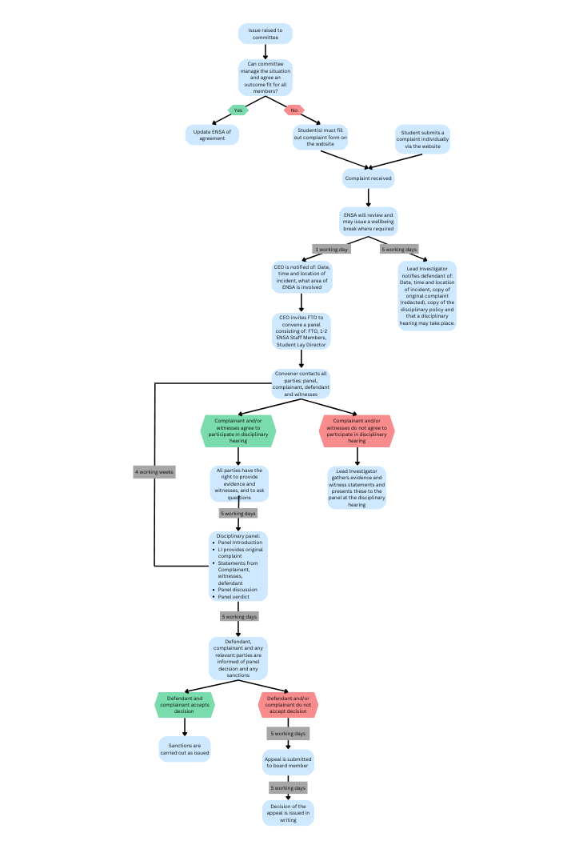

5. Safeguarding & Wellbeing Breaks

5.0. The Lead Investigator, supported by the ENSA CEO, can ask any members involved in a complaint, including complainants, defendant persons and witnesses, to take a ‘wellbeing break’ from Sports Club/Society activities. This is to ensure that appropriate measures are taken to safeguard all members involved.

5.1. As part of a ‘wellbeing break’, those involved may be advised to limit or cease communication with other members, where possible.

5.2. A ‘wellbeing break’ in no way implies guilt or fault by any party.

6. What to expect during a Disciplinary Panel

6.0. Following notification of a complaint, the ENSA CEO will ask the appropriate Full-Time Elected Officer to convene a Disciplinary Panel.

6.1. The panel should consist of:

* The Full-Time Elected Officer as Panel Convener
* A Student Lay Director from ENSA’s Board (or another ENSA student committee member.)
* 1 member of ENSA staff

6.2. The Panel should be held within 4 weeks of the original complaint.

6.3. If a panel member is compromised by a conflict of interest or too much prior knowledge, an alternative Panel Convener may be appointed, as shown in 6.1.

6.4. The Panel Convener will contact all appropriate parties, providing five working days’ notice, to notify them of the arrangements.

6.5. The Lead Investigator may, where appropriate, ask the Panel Convenor to invite additional witnesses to give statements or attend the Disciplinary Panel Hearing.

6.6. The defendant(s) have the right to be accompanied by a fellow ENSA member (an ENU Student.)

6.7. During the Disciplinary Panel Hearing, steps should be taken to ensure that the complainant and witnesses do not interact with the defendant.

6.8. The Lead Investigator will be invited to provide the original complaint, as submitted, along with any evidence or witness statements gathered.

6.9. All parties shall have the right to provide evidence and witnesses, in support of, or against, the complaint(s)/allegation(s), and to ask questions.

6.10. The Panel shall retire to consider the evidence and come to a decision by majority vote.

7. Outcomes and Timescales:

7.0. The Disciplinary Panel may:

7.0.1. uphold the complaint/allegations and impose appropriate penalty/penalties;

7.0.2. suspend the disciplinary process for up to one week to seek further evidence;

7.0.3. dismiss the complaint due to lack of evidence or witnesses;

7.0.4. partially uphold;

7.0.5. not uphold; or

7.0.6. dismiss the complaint as vexatious or malicious and potentially take further action.

7.1. The outcome of a Disciplinary Panel decision, and any penalties imposed, should be communicated in writing to the defendant(s) within five working days of the outcome being decided. This notification should also inform the defendant person(s) they have five working days from the date of this notification to appeal against the outcome, by stating their grounds for appeal and providing evidence for this.

7.2. The outcome of a Disciplinary Panel decision should also be communicated, in writing, to the complainant(s), where appropriate.In cases where a complaint is not upheld, this notification shall also inform the complainant that they have 5 working days from the date of this notification to appeal against the outcome, by stating their grounds for appeal and providing evidence for this.

7.3. A complaint that is deemed vexatious or malicious may also become grounds on which to take disciplinary action against a member; for example, by imposing a period of suspension or even expulsion from membership.

8. Available Penalties

8.0. When a complaint is upheld, it may be appropriate to issue a penalty as outlined below. It may also be appropriate to take further action to rectify a grievance, or mitigate any negative effects or consequences, where possible.

8.1. Available penalties for Office Holders and members include, but are not limited to:

8.1.1. A formal written or personal apology to the complainant.

8.1.2. A fine to cover the cost of damage to the complainant.

8.1.3. A temporary ban or suspension from the Sports Club or Society; or from playing representative sport for a Sports Club.

8.1.4. A ban from holding Sports Club or Society office.

8.1.5. Permanent expulsion from the Sports Club or Society; or from ENSA membership.

8.1.6. Disciplinary proceedings by the University.

8.1.7.Reporting to the Police.

* 1. 8.2. Available penalties for Sports Clubs and Societies include, but are not limited to:

8.2.1. A fine to cover the cost of damage to the complainant.

8.2.2. Suspension of club accounts.

8.2.3. Match ban.

8.2.4. Removal of members from Club Committee.

8.2.5. A referral to the ENSA board with a recommendation that the Sports Club or Society be put on special measures, suspended or dissolved.

8.2.6. Disciplinary proceedings by the University.

9. Appeals

9.0. Appeals, from either the Defendant or Complainant, should be submitted via email to the Lead Investigator.

9.1. Appeals shall be heard by the ENSA CEO, or their appointee, providing they have no connection with or prior knowledge of the circumstances.

9.2. The grounds for appeal against a decision by a Forum Panel may be of the grounds of:

9.2.1. procedural irregularity – the Panel failed to follow procedure;

9.2.2. the Panel’s action being outside of its remit (ultra vires);

9.2.3. the outcome being inconsistent with the outcome or the penalty being too severe, given the offence committed.

9.3. The appeals stage does not re‐hear the whole case but will restrict itself to reviewing the procedure followed and the evidence on which the original decision was made, ensuring that it complied with the agreed procedure and that the outcome was reasonable and lawful.

9.4. An appeal will normally be heard within 10 working days of receiving it. A decision on the appeal, in writing, shall normally be issued within five working days of the decision on the appeal.

9.5. The person hearing the appeal may decide to:

9.5.1. dismiss the appeal, in which case the original decision, and any penalties, shall stand;

9.5.2. review the details of the case, taking account of the appeal; in which case the complaint may then be upheld or dismissed in whole or in part;

9.5.3. determine a different penalty or remedy, specifically where the appeal relates to any penalties or remedies issued.